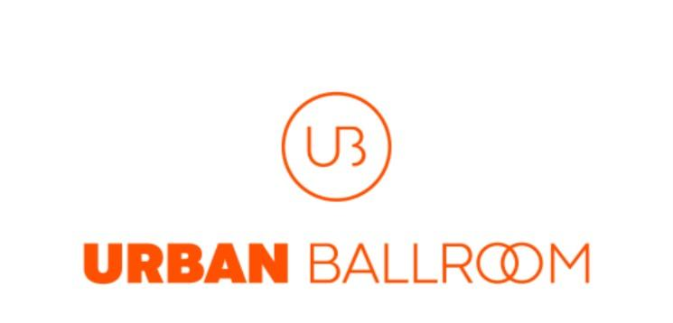

Terms and Conditions

The UrbanBallroom website is operated by Urban Ballroom LTD whose registered office is 10 Elvin Gardens, Wembley Park HA9 0GW. By signing up for a monthly subscription plan, booking a private class or submitting an order for an e-gift card you signify your understanding and agreement of the Terms and Conditions for Urban Ballroom LTD.

- Subscription Contracts

A subscription to UrbanBallroom allows the buyer to have access and receive a product over a determined period of time. UrbanBallroom subscriptions are monthly and begin on the day the payment is received by UrbanBallroom. Payment will then be taken each calendar month unless the subscription is cancelled.

- Subscription Cancellations

If you wish to cancel your monthly subscription you may notify us of your intent to cancel at any time by emailing us on info@urban-ballroom.com. Please note that recurring payments are taken a minimum of 24 hours before your subscription end period so you will need to cancel your subscription prior to this. Your cancellation will become effective at the end of your current monthly billing period.

- Private Classes and Group Bookings Cancellations

If you wish to cancel a private class and/or group booking you may notify us of your intent to cancel by emailing us on info@urban-ballroom.com. To receive a full refund, your notification of intent to cancel must be received by UrbanBallroom at least 48 hours before the scheduled class.

- E-Gift Cards

E-gift cards can be purchased from our website and can be used to purchase products available on our website. These may include a monthly subscriptions, private classes, and items available from our shop up to the value stated on the e-gift card. They may not be exchanged for cash.

- Video Recordings

Our online classes take place on zoom or can be accessed by joining the urbanballoomcommunity Instagram live and may be recorded either on zoom or on Instagram and shared with other members of the UrbanBallroom community. The aim of the recordings is to show the teacher, however, if you are on zoom and speak during the recording, your face may briefly appear on the recording. If you do not wish to be recorded, you may turn your camera off. By signing up to a monthly subscription you agree to the sharing of video recordings for learning purposes.

- Account Suspension and Deletion

We may suspend or delete access to our service immediately, without prior notice, for any reason, including subscription contracts where there has been behaviour which is deemed inappropriate or in violation of our terms and conditions.

- Disclaimer

Use of this service is at your own risk and Urban Ballroom LTD does not accept liability for any injuries incurred during, or as a result of undertaking, the online tutorials and classes. Please take responsibility to ensure you undertake any activities in a safe and secure manner to avoid injuries. It is your responsibility to ensure you are capable of undertaking the activities provided or suggested through the online tutorials and classes.

- Intellectual Property

This website and its original content are and will remain the exclusive property of Urban Ballroom LTD. By using this website and by joining the urbanballroomcommunity Instagram page you agree that all information, communications, photography, images, graphics and logos are for your information and personal use, and as intended by Urban Ballroom LTD.

- Notification of Changes to Terms and Conditions

We reserve the right, at our sole discretion, to modify or replace these Terms and Conditions at any time. By continuing to access our service you agree to be bound by these revised terms.

- Governing Law

These terms shall be governed and construed in accordance with the laws of the United Kingdom.

